

**Modern Topics in IT – IT4020**

**4th Year – 1st Semester**

**Assignment 03 – Report**

**(Augmented Reality)**

|  |  |
| --- | --- |
| **Student ID** | **Student Name** |
| IT19015422 | Perera B.A.A.W.S |
| IT19015040 | Rasuni Wageesha H.A |
| IT18077698 | Thennakoon T.M.B.C.K |
| IT19011608 | Senanayaka S.A.M.A.B.M |

Submitted to

Sri Lanka Institute of Information Technology

Table of the Content

List of Figures 2

Contribution 3

1. Screenshots of Individual Applications & Final application 4

• IT19015422 4

• IT19015040 5

• IT18077698 6

• IT19011608 7

Final Application 8

2. Codes of Individual Applications & Final Application 9

• IT19015422 9

• IT19015040 9

• IT18077698 10

• IT19011608 10

Final Application 11

3. Small write-up about the real-life problem 12

# List of Figures

Figure 1.1: Screenshots of Individual Application (Sigiriya) 4

Figure 1.2: Screenshots of Individual Application (Anuradhapura) 5

Figure 1.3: Screenshots of Individual Application (Temple of the Tooth) 6

Figure 1.4: Screenshots of Individual Application (Yala National Park) 7

Figure 1.5: Final Application 8

Figure 2.1: Individual Application (IT19015422) 9

Figure 2.2: Individual Application (IT19015040) 9

Figure 2.3: Individual Application (IT18077698) 10

Figure 2.4: Individual Application (IT19011608) 10

Figure 2.5: Final application code part 1 11

Figure 2.6: Final application code part 2 11

## Contribution

|  |  |  |
| --- | --- | --- |
| **IT Number** | **Student Name** | **Contribution** |
| IT19015422 | Perera B.A.A.W.S | * Create a simple augmented reality app. * Make an own marker. * Download the source and texture files to create own artifact. * Use augmented reality principles to display 3D artifacts. * Make an individual application and the report. |
| IT19015040 | Rasuni Wageesha H.A | * Create a simple augmented reality app. * Make an own marker. * Download the source and texture files to create own artifact. * Use augmented reality principles to display 3D artifacts. * Make an individual application and the report. |
| IT18077698 | Thennakoon T.M.B.C.K | * Create a simple augmented reality app. * Make an own marker. * Download the source and texture files to create own artifact. * Use augmented reality principles to display 3D artifacts. * Make an individual application and the report. |
| IT19011608 | Senanayaka S.A.M.A.B.M | * Create a simple augmented reality app. * Make an own marker. * Download the source and texture files to create own artifact. * Use augmented reality principles to display 3D artifacts. * Make an individual application and the report. |

## Screenshots of Individual Applications & Final application

### IT19015422

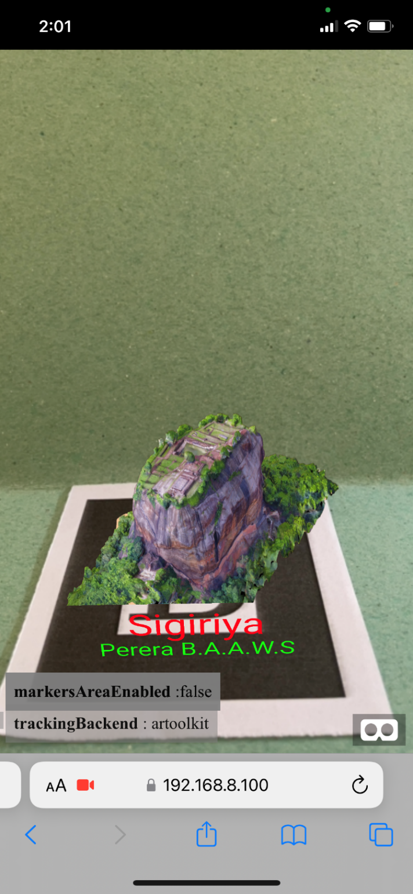

Figure 1.1: Screenshots of Individual Application (Sigiriya)

### IT19015040

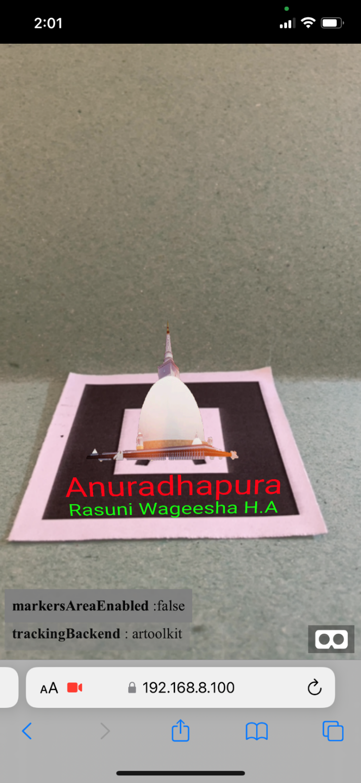

Figure 1.2: Screenshots of Individual Application (Anuradhapura)

### IT18077698

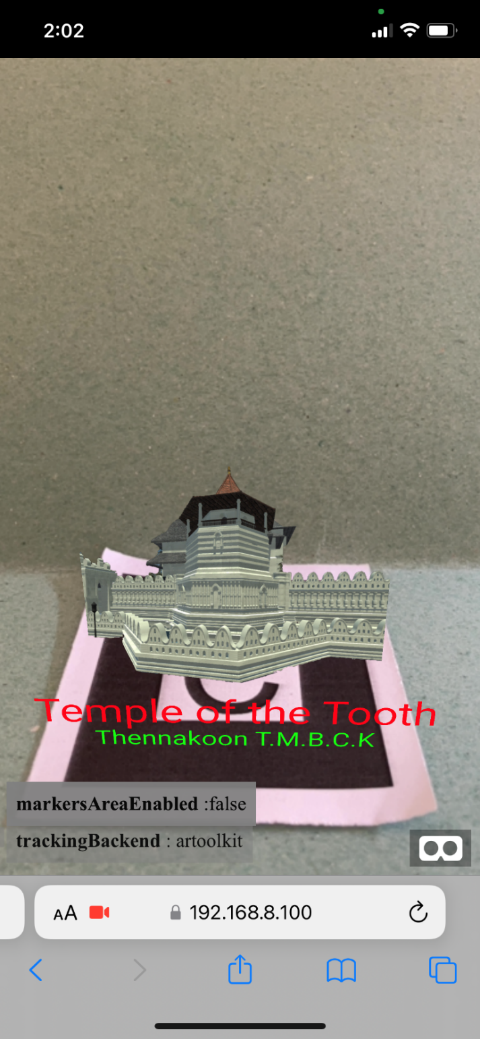

Figure 1.3: Screenshots of Individual Application (Temple of the Tooth)

### IT19011608

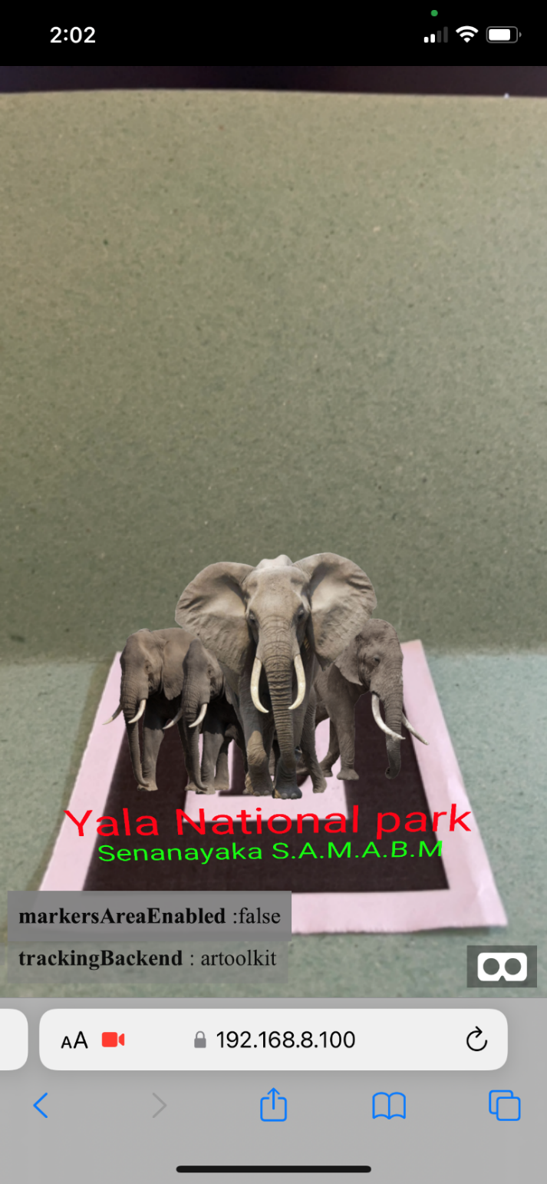

Figure 1.4: Screenshots of Individual Application (Yala National Park)

### A screenshot of a video game Description automatically generatedFinal Application

Figure 1.5: Final Application

## Codes of Individual Applications & Final Application

### IT19015422

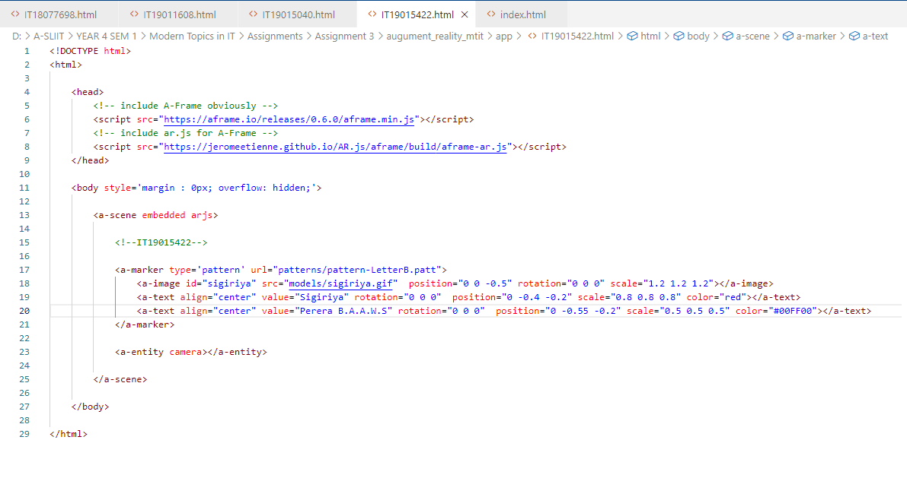

Figure 2.1: Individual Application (IT19015422)

### IT19015040

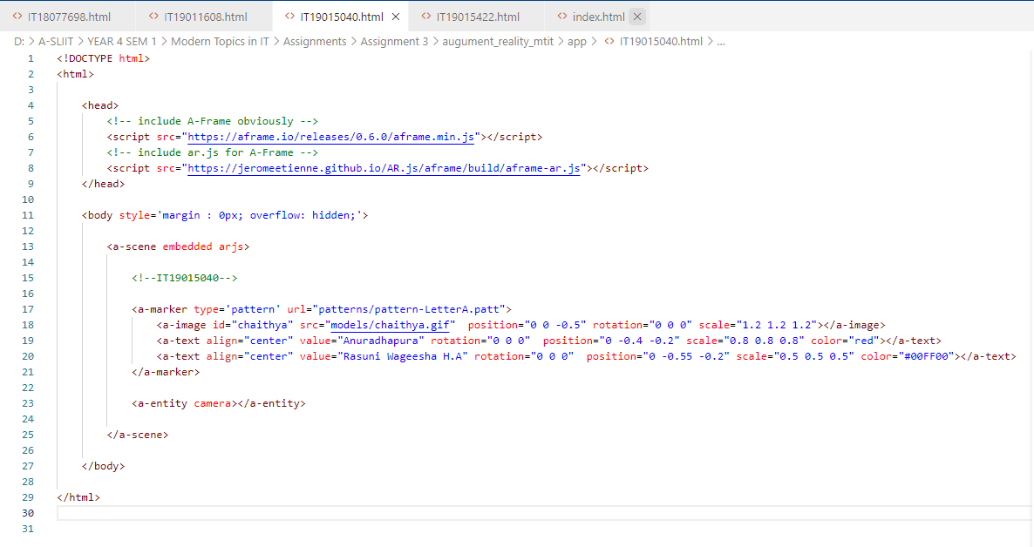

Figure 2.2: Individual Application (IT19015040)

### IT18077698

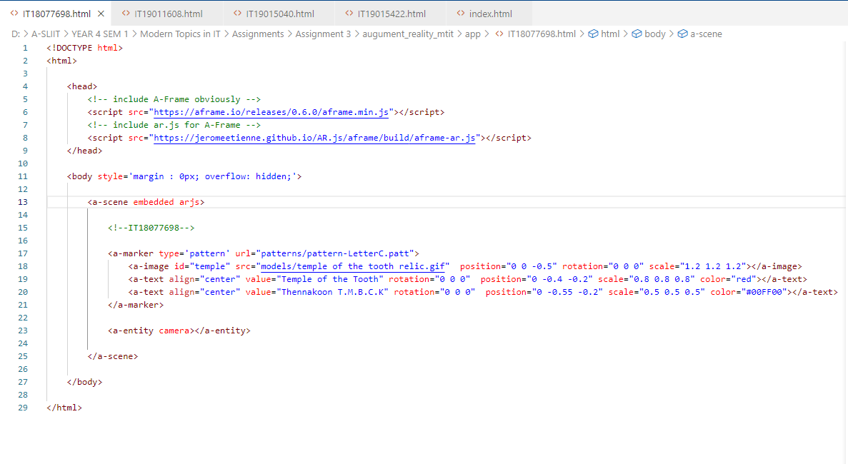

Figure 2.3: Individual Application (IT18077698)

### IT19011608

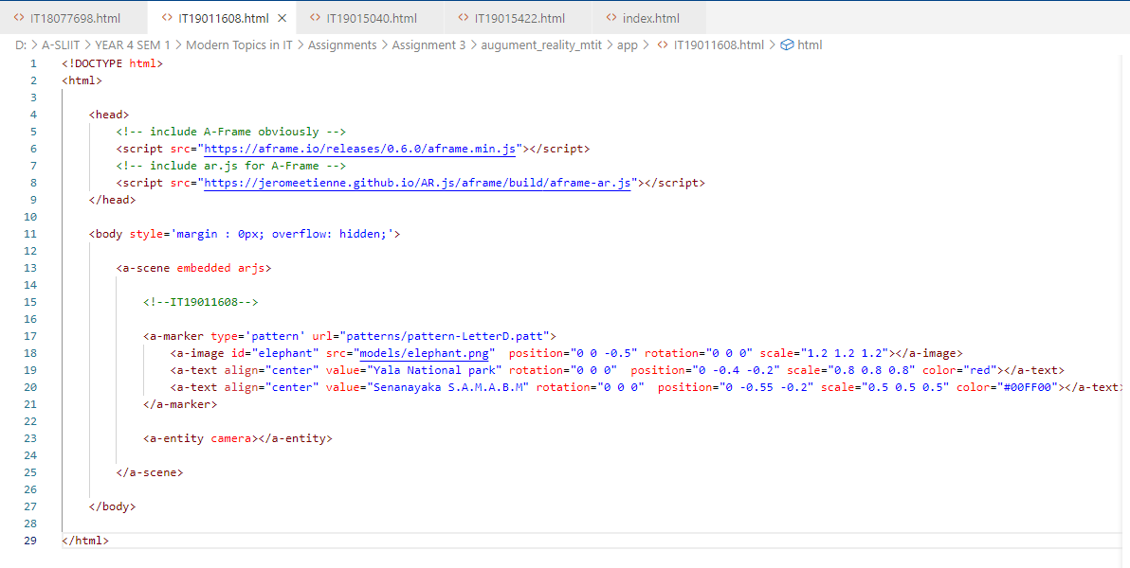

Figure 2.4: Individual Application (IT19011608)

### Final Application

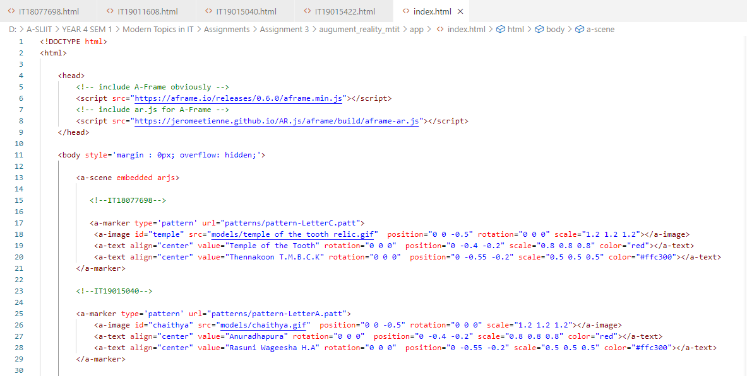

Figure 2.5: Final application code part 1

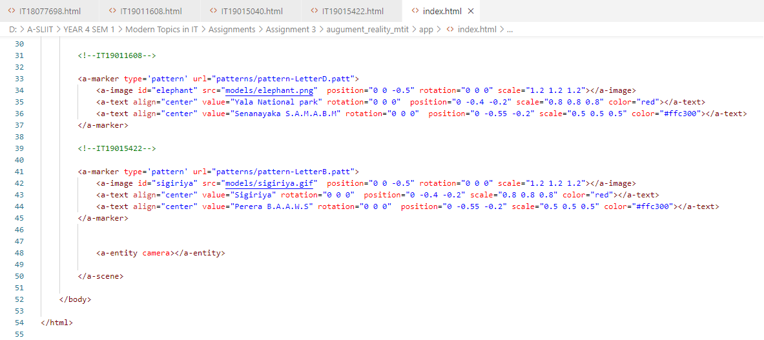

Figure 2.6: Final application code part 2

## Small write-up about the real-life problem

Sri Lanka is a popular tourist destination because it offers a diverse range of wildlife, a rich cultural legacy, and breathtaking scenery. Sri Lanka attracts thousands of tourists each year. There are several wildlife parks in the area. Yala National Park is one of them. Tourists like watching wild animals roaming freely in their natural habitat. Sri Lanka has a 2,500-year-old history. Anuradhapura, Polonnaruwa, Sigiriya, Kandy, and other ancient cities have ruins. Tourists come to view beautiful sculptures, paintings, and the ruins of historic buildings and monuments.

During the pandemic situation, the tourism industry had fallen down not only Sri Lanka that happened to the whole world. But now it's going stable like previous years. In this assignment we focus to show the most amazing places in Sri Lanka that get more attraction among the tourists.

There are a lot of photographs of tourism places on the internet, but there is a lack in the inspections. To overcome this problem, we may develop some scanning markers using 3D representations of tourism places and Augmented Reality technologies. Anyone who interest about those kinds of places may just scan the marker to get a 3D image of the tourism places in a realistic environment, which will help to get attraction from the tourists.